ZZSC9020 – Project Meeting 2: (Week 1 - 2nd meeting): Agenda
Project: Electricity Demand Forecasting (NSW) by Group A
Meeting Date: March 19, 2026 (Tuesday)
Time: 7:30pm – 8:30pm
Location / Platform: MS Teams Meeting
Attendees: Brendan, Daniel, Kam, Kelvin
- Week 1 first meeting minute and reporting of progress:
- Assessment 1B – Software Agreement (due March 24, 2025)
- Assessment 1A – finalization of project plan (due March 24, 2025)
- Discussion of forecasting horizon (put in item 2 below)
- Progress of literature review
2. Decision on forecasting horizon
3. Change in Timeline and Milestones (if any)
4. Action Items and Next Steps
5. Next Meeting date and time

ZZSC9020 – Project Meeting 2: (Week 1 - 2nd meeting): Minutes
Project: Electricity Demand Forecasting (NSW) by Group A
Meeting Date: March 19, 2026 (Tuesday)
Time: 7:30pm – 8:30pm
Location / Platform: MS Teams Meeting
Attendees: Brendan, Daniel, Kam, Kelvin
- Week 1 first meeting minute and reporting of progress:
- Assessment 1B – Software Agreement (due March 24, 2025)
 | Justification
- Meeting Software  – MS Teams | - Multifunction (chat, video, file sharing with University account) for efficient coordination and communication;  - Can schedule meeting and record meeting, with live caption;  - Compatible with University OneDrive.
- Collaboration Tools  – GitHub | - With version control,  - Collaborative development through branches and pull requests, avoid conflicts,  - With tracking and project management features
- Data Analysis Software  – Python | - Various choices of useful libraries (Pandas, NumPy, Scikit-learn, PyTorch etc),  - Suitable for coding statistical models and machine learning models,  - Rich resources in Python available in GitHub
- Reproducible Report Writing  – Jupyter Notebook  + MS Word | - Jupyter Notebooks allows integration of codes, outputs, explanations in a reader-friendly format,  - Microsoft word provides flexibility for academic report writing
- Oral Presentation Software  – Powerpoint  + Recording Software | - PowerPoint enables clear visual communication of key findings,  - Recording software enable asynchronous presentation delivery and teammates individual part can be edited easily into one single video,  - Allows rehearsal, re-take, correction, refinement with flexibility.
- Additional Software

- Assessment 1A – finalization of project plan (due March 24, 2025):
ongoing refinement (to be completed before due date March 24, 2026)

- Progress of literature review – Partially completed. As this is part of the project plan, it is to be completed together with Assessment 1A.

- Decision on forecasting horizon
- Acknowledged as an important factor affecting:
  - Model selection
  - Usefulness of seasonal models
- No final decision made → to be revisited after literature review during the coming week.
- Kelvin found 2-3 papers with the test structure:
 | Horizon 1  2-3 days | Horizon 2  around 10 days | Horizon 3  30-40 days
Model 1 RMSE  Model 1 MAE | …… | …… | ……
Model 2 RMSE  Model 2 MAE | …… | …… | ……
Model 3 RMSE  Model 3 MAE | …… | …… | ……
Model 4 RMSE  Model 4 MAE | …… | …… | ……

- Modelling Approach Discussion
- Discussion on whether simple polynomial regression could be sufficient for time series forecasting.
- Consideration that:
  - Polynomial regression is a basic benchmark model.
  - It may reduce the need for more complex models like SARIMAX.
- SARIMAX was previously selected:
  - Advantage: captures seasonality
  - Concern: may not be necessary for short forecasting horizons
- Decision:
  - Review relevant research papers to confirm modelling choices before finalising.

- Task Allocation
- Literature Review
  - Brendan: condense and merge all literature review sections
- Introduction
  - Kelvin: draft initial version
  - Brendan: may refine / co-develop
  - Kam: available to assist
- Methodology
  - To be reviewed:
    - Ensure alignment with project plan
    - Adjust based on modelling decisions

- Coordination & Communication
- Kelvin to:
  - Share research papers with team
  - Share updated documents (agenda, tools, schedule)
- Team to continue discussions via Teams messages

- No change in Timeline and Milestones (if any)
Week | Activities | Milestone
Week 1 | - Form project team,  - Discuss project scope and research question,  - Conduct preliminary literature review,  - Finalize project plan,  - Confirm approaches, dataset and variables | Project plan finalized
Week 2 | - Data cleaning,  - Preprocessing,  - Exploratory data analysis,  - Prepare implementation checklist | Implementation checklist prepared
Week 3 | - Implement and evaluate SARIMAX baseline model  - Implement LSTM model and tune hyperparameters  - Implement PatchTST model and draft comparison of model performance  - Prepare individual reflection portfolio | 1. Model set up with results  2. Individual reflection portfolio completed
Week 4
Week 5 | - Conduct forecasting experiments,  - Draft report, and  - Prepare presentation | Results and implications agreed
Week 6 | Finalize report and prepare presentation | Report finalized
Week 7 | Finalize video presentation | Videos finalized

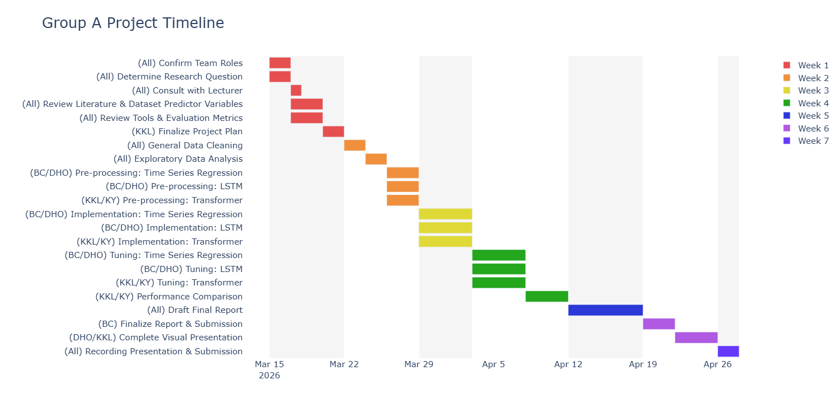

7. Action Items & Next Steps
Brendan and Daniel: Review papers on polynomial regression vs time series models
All:
- Finalize forecasting horizon (e.g. 2 days to 30 days according to some papers?)
- Preliminary model study (SARIMAX vs LSTM vs Transformer)
- Complete introduction, consolidated literature review, methodology of project plan.

8. Next Meeting date and time
Meeting Date (internal): March 27, 2026 (Friday) starts 7:30pm MS Teams
Meeting Date (with lecturers): TBC

